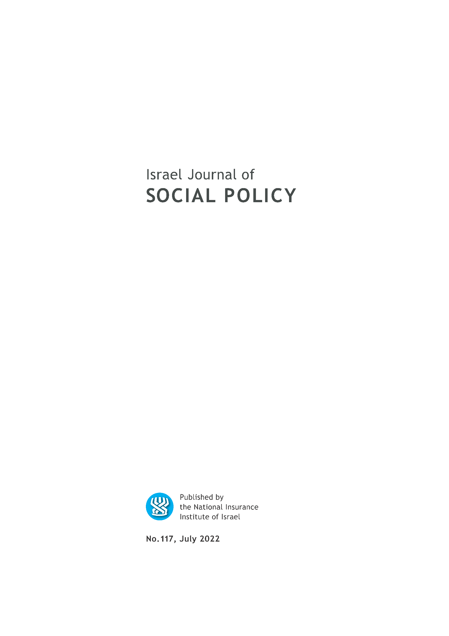

EDITORIAL BOARD

Israel (Issi) Doron, Editor in chief
Nitsa (Kaliner) Kasir, Chairman
Suliman Abu Bader
Leah Achdut
Jon Anson
Liat Ayalon
Orly Benjamin
Nissim Cohen
Sylvie Fogiel-Bijaoui
John Gal
Jochanan Stessman
Aviad Tur-Sinai

Managing Editor: Maya Orev-Attal
Typesetting: Onit Computer Services Ltd.

Contents
Renewing public management: Is the future already here? State governance in the post-COVID-19 era
Eran Vigoda-Gadot
Parents who worked from home during the COVID-19 pandemic: role conflict and marital aggression
Liat Kulik and Dan Ramon
Children removal from home by court order: implications on Arab mothers from East-Jerusalem
Nada Omar and Tehila Refaeli
“Engineering volunteerism”: corporate volunteering in non-profit organizations
Noga Pitowsky-Nave, Michal Almog Bar and Hillel Schmid
Directors in a trap: policy practice in social service departments
Sivan Levy, Ayelet Makaros and Nehami Baum
Employment and vocational training mobility: public stances, labor market and policy trends
Shlomo Mizrahi and Dana Natan Krup

Summaries of the main articles

Renewing public management: Is the future already here? State governance in the post-COVID-19 era
Eran Vigoda-Gadot

This short article deals with recent theoretical, paradigmatical, and practical transformations in public management, especially in view of the global COVID-19 crisis. The paper is divided into two major sections. First, I briefly review developments in managerial thinking within the public and governmental arena, especially since the 1970s, emphasizing various paradigmatic and interdisciplinary influences, and the unique challenges related to the governance of democracies in rapidly changing environments. The next section tries to evaluate the impact of the COVID-19 crisis on the way public management evolves, highlighting transformations in social environments, the growing impact of digitization, technology, and the information society. In light of these considerations, seven potential directions and challenges for the ongoing progress of the field are suggested.

Parents who worked from home during the COVID-19 pandemic: role conflict and marital aggression
Liat Kulik and Dan Ramon²

The present study investigates the correlation between the experience of work-family role conflict during the COVID-19 pandemic and expressions of marital aggression. Expressions of aggression were assessed in terms of hostility in current spousal relationships and adopting inappropriate marital conflict management patterns: physical violence, verbal-emotional violence and avoiding conflict resolution. The research sample included 406 Jewish participants (206 women and 200 men) who worked from home at least three days a week during August 2020, and are parents to young and middle-childhood age children. The findings indicate a positive correlation between role conflict, marital hostility and the use of a pattern of verbal-emotional violence during conflict management.
Furthermore, we observe that marital hostility mediates the relationship between role conflict and the use of inappropriate marital conflict management patterns. A negative correlation was also found between resources of flexibility in crisis management and relaxed communication in the family, on one hand, and marital hostility and to use of physical violence patterns in marital conflict management. No differences were found between mothers and fathers in terms of role conflict experience or assessment of expressions of marital aggression.

Children removal from home by court order: implications on Arab mothers from East-Jerusalem
Nada Omar and Tehila Refaeli³
Arab women from East-Jerusalem live in a traditional and patriarchal society and most of them fulfil traditional duties as wives and mothers. If their children are removed for out-of-home placements, the cultural and political context of their lives differentiates their experiences from those of other mothers who live in Western societies. This study aims to examine the implications of institutionalizing children on Arab mothers from East-Jerusalem in different aspects of their lives: personal, familial and social. In-depth semi-structured interviews were conducted with 15 Arab mothers from East-Jerusalem from whom at least one child was removed to out-of-home placement by an Israeli court order, for a period of over four years. The mothers described a variety of implications on their lives as a result of their children’s removal, including emotional distress and health impacts. They experienced an increase in violence against them from their biological families, their spouses and their spouse’s families.
Socially, the mothers experienced banishment and criticism as ones who try to abandon their motherly duties. The effects of child removal for out-of-home placement on Arab mothers are vast, either because being a mother is their main societal expectation, or considering the abuse experienced by those women throughout their lives. The study highlighted the need to design interventions with these women according to their unique characteristics and to promote their empowerment.
Key words: Out-of-home removal; mothers; East-Jerusalem; cultural aspects; personal, familial and social effects

“Engineering volunteerism”: corporate volunteering in non-profit organizations
Noga Pitowsky-Nave, Michal Almog Bar and Hillel Schmid⁵

Corporate volunteering refers to corporate employees volunteering in the community on behalf of their workplace, as part of a corporate social responsibility strategy. These voluntary activities usually take place in non-profit organizations (NPOs) that provide services to vulnerable populations, such as people with disabilities and health problems, and children and youth at risk. Similar to emerging global trends, corporate volunteering is a rapidly growing phenomenon in Israel, and yet it has received little scholarly attention. The aim of the present study is to examine the meaning of corporate volunteering from the perspectives of the main stakeholders involved: corporate executives and volunteers; NPO leaders, employees and service users.
The research draws on three qualitative case studies. The first is a community garden (2015-2016), which involved real-estate company employees volunteering in a mental health rehabilitation NPO. The second case study is a transportation service (2006-2018), in which insurance company employees volunteered in a medical aid NPO, transporting people with chronic illness to hospital treatments. The third case study is a farm (2014-present), in which employees from an irrigation technology company volunteered to provide at-risk youths with an opportunity to work in agriculture.
Data for this study were collected from 2016-2019 using mixed methods. Semi-structured in-depth interviews were held with key stakeholders: executives, employees, corporate volunteers as well as service users (N = 28). We also conducted observations within the organizations and at joint events. Finally, we analyzed a variety of relevant documents, including meeting minutes, emails, letters, and social media posts. The data collected were analyzed qualitatively in two stages: within-case followed by a cross-case analysis.
The findings provide a glimpse into the “backstage” of corporate volunteering, indicating that business executives perceive it as a meaningful activity that contributes to community welfare and company reputation. Nevertheless, our results also indicate that volunteering took place mostly on a sporadic base – once a month or once a quarter – with significant turnover of volunteering employees. The business companies struggled with substantial difficulties in recruiting and retaining volunteers, in some cases leading them to actually force employees to "volunteer" in these activities.
For these reasons, corporate volunteering did not achieve a meaningful encounter between corporate employees and NPO service users, but was limited to the concrete activities carried out, with limited social interaction. Thus, the findings demonstrate a significant gap between the positive perception of corporate volunteering in the literature and the reality on the ground, in which volunteering offers only limited benefits.

Directors in a trap: policy practice in social service departments
Sivan Levy, Ayelet Makaros⁶ and Nehami Baum⁶

Background: As a welfare state, Israel is coping with many social challenges. Social workers who are closely acquainted with the needs of disadvantaged populations are expected to engage in policy practice in order to improve the situation of their clients. Even though they have witnessed the positive and negative consequences of social policy, only a few of them actually engage in policy practice. The few studies that have examined this issue indicate that one of the factors that influence the involvement of social workers in policy practice is support from directors of social service departments and legitimization of engagement in policy practice.
Aims: To examine the perceptions of social service department directors regarding the role and involvement of the departments in policy practice.
Method: The findings are based on thematic analysis of semi-structured interviews conducted with 13 directors of social service departments in Israel.
Findings: The findings reveal a structural trap that makes it difficult for social workers as well as for directors to engage in policy practice in order to promote changes beyond the level of the individual and family.
Implications for policy and practice: It is recommended to establish a national reflection forum consisting of representatives of department directors, local authorities, and the Ministry of Social Affairs who will discuss the significance of departments’ engagement in policy practice. In addition, it is recommended to develop training programs for both directors and workers in order to provide them with knowledge and skills on the topic.

Employment and vocational training mobility: public stances, labor market and policy trends
Shlomo Mizrahi and Dana Natan Krup⁷

One of the main challenges in modern labor markets is to improve the mobility and employability of workers among workplaces, jobs and roles. This paper explores the factors that might influence people's beliefs about and attitudes towards the mechanisms for improving employability through training. We develop a research model and test it in Israel using surveys that were distributed at two points in time – before and during an acute crisis in the labor market – the Covid-19 pandemic, and evaluate the influence of the Covid outbreak on the research variables. Although citizens are aware about the need to improve employability, they are less willing to promote or pay for it. Perceptions about personal mobility and employability, as well as about employment security, play a major role in explaining citizens' attitudes towards training. Beliefs about the effectiveness of government training providers can influence on citizens’ demand for training. We also reveal a paradox whereby people support training, but also feel that widespread training might reduce their competitive advantage in the labor market.
Although the unemployment rate increased dramatically following the Covid-19 outbreak, the relationships between the research variables are almost identical at the two points in time. Our findings indicate that employment status is related to citizens' perceived employment security and their attitudes toward training. Previous educational experience, education and training have a role in perceived employment security and indirectly affect support in training. Policy implications follow.

Division of Public Administration and Policy and the Center for Public Management and Policy, School of Political Science, University of Haifa
School of Social Work, Bar Ilan University
School of Social Work, Ben-Gurion University of the Negev
School of Social Work, Sapir Academic College
The Paul Baerwald School of Social Work and Social Welfare, Hebrew University of Jerusalem
The Louis and Gabi Weisfeld School of Social Work, Bar-Ilan University
Department of Public Administration and Policy, School of Political Sciences, University of Haifa

