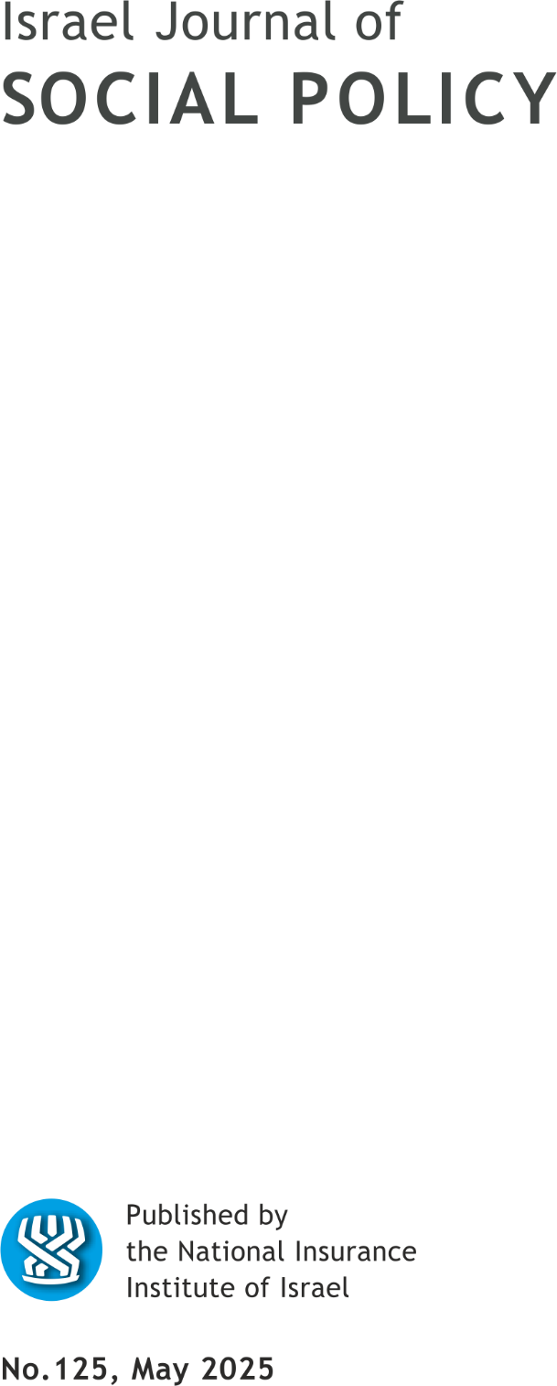

EDITORIAL BOARD

Nissim (Nessi) Cohen, Editor in chief
Nitsa (Kaliner) Kasir, Chairman
Suliman Abu Bader
Leah Achdut
Jon Anson
Liat Ayalon
Orly Benjamin
Sylvie Fogiel-Bijaoui
John Gal
Jochanan Stessman
Aviad Tur-Sinai

Managing Editor: Maya Orev-Attal
Typesetting: Onit Computer Services Ltd.

Contents
Work-home balance among parents of children with disabilities:
A call for policy change
Limor Gadot, Einav Segev and Maayan Fine
Peer support providers in Israel: The main challenges
and critical components for implementing optimal peer support in mental health services
Inbar Adler Ben Dor and Galia Moran
Professional mothers and professional/lay women: Dual care work of health professionals who are mothers of children with disabilities
Rotem Levy Heiman
Welfare, policy, multi- and interdisciplinarity in law
Yael Efron, Yossi Korazim-Kőrösy and Mohammed S. Wattad
Does the income pattern matter? Differences in the behavior and experiences of women in the family-work system according to earning patterns and social sectors in Israel
Liat Kulik

Summaries of the main articles

Work-home balance among parents of children with disabilities: A call for policy change
Limor Gadot, Einav Segev1 and Maayan Fine1

Work is considered a central activity in the life of an adult, fulfilling economic, psychological, and social needs. However, maintaining a balance between home and work demands contributes to a better quality of life. This balance can be disrupted for parents of children with disabilities due to the need to address the child’s specific needs and the broader implications of the disability on their lives. Despite legislation defining the rights of these parents in the labor market, recent studies indicate that such legal measures are insufficient. Parents of children with disabilities tend to earn less, have lower levels of education, and face greater challenges in maintaining job stability. Additionally, they experience heightened parental stress and significant work-home imbalance. This article aims to highlight the unique needs of these parents in the workplace, examine current policies addressing their challenges, and propose recommendations for necessary policy changes.

Peer support providers in Israel: The main challenges and critical components for implementing optimal peer support in mental health services
Inbar Adler Ben Dor and Galia Moran

Background: In recent years, a recovery-oriented approach has been implemented in the mental health system, of which a central component is the employment of peer providers (peers). Optimal integration of peers in MH services contributes to service users, peers and organizations, in promoting personal recovery and a recovery-oriented and person-centered approach in organizations. However, many organizational challenges curtail the potential contribution of peers.
Objective: To identify the challenges and critical components for implementing optimal peer support in Israel based on a recovery orientation.
Research method: As part of the international UPSIDES project, qualitative research was implemented with 68 different stakeholders in the mental health rehabilitation system through 10 focus groups and 12 interviews. A thematic analysis was performed using MAXQDA 2020 software. Analysis was guided by the CFIR conceptual framework used to explain intervention implementation (Damschroder et al., 2009).
Findings: Challenges were identified under five areas of the CFIR framework: characteristics of the intervention, external setting, internal setting, stakeholder involved and implementation factors. These included for example: lack of adequate policy, crises, lack of professionalization and stigma. In addition, promoters were identified in all areas of CFIR apart from the characteristics of the intervention. These included for example: directors, commitment, adjustments, supervision, opportunities for expressing unique knowledge.
Conclusions and implications for practice and policy: Optimal implementation of peer support requires full organizational commitment that includes a directed organizational culture alongside organizational practice – arrangements and infrastructures including training, supervision and guidance for all parties in the organization. To support organizations, there is a need for policy that translates into the development of designated roles and the allocation of resources that will contribute to the establishment of recovery-oriented and person-centered rehabilitation services.

Professional mothers and professional/lay women: Dual care work of health professionals who are mothers of children with disabilities
Rotem Levy Heiman

Issues of professional and lay knowledge of mothers regarding the care for children with disabilities have been a subject of sociological research for several decades. These studies concentrated on the perspectives of professional women or mothers, yet none explored the intersection of these types of knowledge in women who are professionals in the field of caring for children with disabilities, as well as mothers themselves: 'mother-clinicians'. This article seeks to examine the convergence between these forms of knowledge and the practices that emerge from this intersection, focusing on mother-clinicians in the field of pediatric rehabilitation in Israel.
The study employs qualitative methods and is based on a critical-feminist paradigm. Fourteen in-depth semi-structured interviews were conducted with pediatric speech language pathologists, occupational therapists, and physical therapists who are also mothers of children with disabilities. Thematic analysis was used to analyze the data.
From the findings, four types of knowledge emerged that mother-clinician described: research-based academic knowledge, experiential knowledge, knowledge from personal experience, and social knowledge. Mother-clinicians wove the two different types of knowledge, acquired in their dual roles as mothers and professional caregivers, into their practices in both realms. The research findings illustrate the knowledge-based practices of mother-clinicians in each arena. In their maternal role, they extensively applied knowledge derived from professional practice – encompassing both academic and experience-based insights. Additionally, in their professional care work, they utilized practices rooted in experiential knowledge and knowledge from motherhood experiences. The practices used by the participants demonstrate the ability to merge knowledge components into the various roles in their care work, both as mothers and as professionals.
From the research findings, the intersection of caregiving roles serves as an arena for generating novel knowledge, positioning mother-clinicians as authorities on maternal knowledge, while portraying professionals as lay-people within the realm. This unique case study demonstrates how the interweaving of professional and lay knowledge enables an understanding of the different types of knowledge and their hierarchies. It also highlights the potential for blurring these hierarchies and the mutual enrichment made possible by this integration.

Welfare, policy, multi- and interdisciplinarity in law
Yael Efron, Yossi Korazim-Kőrösy and Mohammed S. Wattad

The article deals with the understanding of the concepts “discipline”, “multidisciplinarity”, and “interdisciplinarity” in the context of welfare legislation and social policy. A discipline is an area bounded by certain boundary lines, with its community of experts, unique language, values, and methods. Disciplines tend to maintain their boundaries and protect them from outside intrusion. However, complex social phenomena require the integration of several fields of knowledge and interdisciplinary collaborations of different capacities. The multidisciplinary approach allows for a holistic and systemic view of complex situations but is challenging to implement due to the strict boundaries of the fields. In recent decades, the recognition that solving complex problems requires an interdisciplinary integration of knowledge has expanded. Interdisciplinarity refers to some synthesis between different fields and promotes the development of new knowledge based on a combination of existing fields. The various fields develop unique cultures, so there is difficulty in combining them. However, the article points out that welfare legislation requires a combination of different fields of knowledge such as law, social work, and public policy, and offers insights to coping with these challenges.

Does the income pattern matter? Differences in the behavior and experiences of women in the family-work system according to earning patterns and social sectors in Israel
Liat Kulik

This study aims to explore variations in women’s experiences within families characterized by different earning patterns: either where the man earns more, or both spouses earn equally, or the woman earns more. The research encompasses three key sectors in Israeli society: the general Jewish population, ultra-Orthodox communities, and the Arab sector. The analysis focused on three dimensions of the family–work system: behavioral (time allocation to family and paid work), cognitive (assessment of role conflict between family and work), and affective (marital satisfaction). The findings reveal that women who earned more than their spouses tended to dedicate more hours to paid work and less to family responsibilities across all sectors. However, based on the findings, husbands consistently allocated equal hours to family responsibilities, irrespective of their social background or earning patterns. Additionally, Arab women with equal or lower earnings compared to their spouses experienced heightened role conflict between work and family compared to other earning patterns. In contrast, ultra-Orthodox women reported the highest levels of marital satisfaction, regardless of their earning patterns. In conclusion, this study highlighted that earning patterns impact women’s experiences in balancing family and work responsibilities. However, women in all sectors predominantly carried the primary burden of family care. To support women, especially in traditional sectors, organizations are encouraged to implement family-friendly policies.
Key words: Earning Patterns, Ultra-Orthodox Sector, Arab Sector, Role Conflict, Marital Satisfaction

School of Social Work, Sapir Academic College
Department of Social Work, Ben Gurion University of the Negev; the Bob Shapell School of Social Work, Tel-Aviv University; School of Social Work, Bar-Ilan University
Department of Social Work, Ben Gurion University of the Negev
School of Education, Ben Gurion University of the Negev
Faculty of Social and Education Sciences, Ramat-Gan Academic College
Department of Social Work, Zefat Academic College
Ramat-Gan Academic College
Bar-Ilan University and Netanya Academic College

