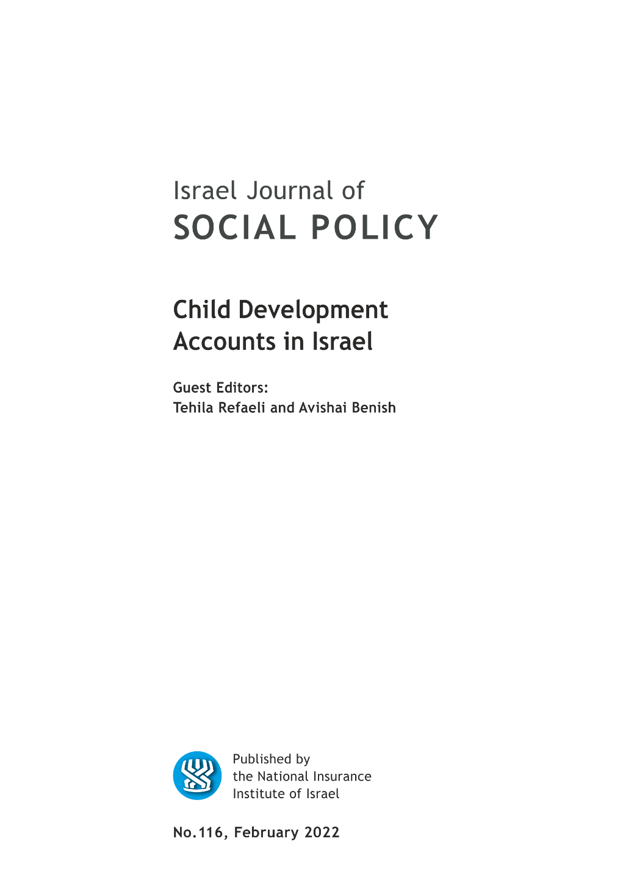

EDITORIAL BOARD

Israel (Issi) Doron, Editor in chief
Nitsa (Kaliner) Kasir, Chairman
Suliman Abu Bader
Leah Achdut
Jon Anson
Liat Ayalon
Orly Benjamin
Nissim Cohen
Sylvie Fogiel-Bijaoui
John Gal
Jochanan Stessman
Aviad Tur-Sinai

Managing Editor: Maya Orev-Attal
Typesetting: Onit Computer Services Ltd.

Contents
Early enrollment and participation in the Savings for Every Child program: evidence from the program rollout
Michal Grinstein-Weiss, Ofir Pinto , Olga Kondratjeva, Stephen Roll1, Sam Bufe1 and Talia M. Schwartz-Tayri
The Israeli Universal Child Development Account (UCDA) - its implementation and policy implications
Daniel Gottlieb
Redistribution and the politics of welfare policy financialization: the case of "Savings for Every Child" program
Ronen Mandelkern and Zeev Rosenhek
Like savers: the paradox of inclusion in asset-building programs
Guy Feldman
Analyzing the development of the "Savings Plan for Each Child" policy: how a window of opportunity was seized in the policy-making process
Tehila Refaeli
"Savings for Every Child?" – Review about youth at risk and young adults' situation
Liron Eshel and Shiran Reichenberg
Savings for Every Child: a child-focused program and its influence on children and families living in poverty
Yuval Saar-Heiman

Summaries of the main articles

Early enrollment and participation in the Savings for Every Child program: evidence from the program rollout
Michal Grinstein-Weiss, Ofir Pinto, Olga Kondratjeva¹, Stephen Roll¹, Sam Bufe1 and Talia M. Schwartz-Tayri

Child Development Accounts (CDAs) are bank or investment accounts typically opened at birth or during a child’s early years with the aim of promoting savings and asset accumulation for child development purposes, such as post-secondary education or homeownership. Beginning in January of 2017, the Israeli government established a universal CDA program called the Savings for Every Child Program (SECP). Under the program, every Israeli child gets a personal investment fund into which the government makes monthly contributions, and parents can further opt to make additional monthly deposits and change the default deposit location for these funds (e.g., a bank account versus an investment fund). Using population-level administrative data, this paper examines SECP enrollment and participation patterns for the first six months following the program’s inception. We observe generally high rates of program participation among SECP-eligible households. However, we also find that more affluent, better educated, more employed, and ethnic majority households tend to engage with the program at higher rates and in ways that will likely yield higher economic returns in the future. These results indicate that while the SECP may increase the overall financial security of Israelis, it may also contribute to growing economic inequality.

The Israeli Universal Child Development Account (UCDA) - its implementation and policy implications
Daniel Gottlieb

In early 2017, a Universal Child Development Account (UCDA) was started in Israel after a similar program had been suggested by the Research Department of the National Insurance Institute (NII) following an international workshop held at the department in 2009. The NII's proposal, though accepted by the 'war on poverty' commission in 2013, was only considered by the government in 2015 following a deep cut in child benefits in August 2013 and after the Ultra-orthodox parties' insisted on the reinstalment of the amount as a universal CDA. The program that was finally implemented includes monthly deposits of NIS 50 out of the child benefit, in a dedicated savings account, either in a bank or a provident fund in one of several financial institutions, participating in the program. The program, administrated jointly by the NII and the Finance ministry, gives the children access to expected future income from the capital market. The accumulated funds after 18 years hopefully create an incentive for the grown-up child to use the benefits for human capital accumulation. Such a policy can help strengthen the child's future earnings capability and thus add to the individual’s economic success and also to the social insurance's financial sustainability. However, as shown in this paper, such a policy is not without risks. The parents are required to make several choices – they are supposed to choose a savings path for each of their children – either open a savings account in a bank or invest in a provident fund of one of the eligible investment firms. The various savings paths differ in their combination of risk and return on the investment. The investment period for a newborn child is 18 years and extendable to 21 years. Parents can add a monthly deposit of 50 NIS, out of the current child benefit. For parents, who do not choose a savings or investment path, a default decision is activated. As shown here, the design of the default has important implications on the distributional outcome of the program. The long run success depends therefore on the degree of the parents' financial literacy. The latter, depending among other things on the parents' socio-economic background. It seems that an important shortcoming of the specific implementation is that observed choices by the parents hint at the creation of an advantage for affluent families, while disadvantaged families, who happen to be in high need of social insurance, may fall behind. Opportunities and difficulties arising from a CDA policy are discussed, stressing the importance of the policy design, necessary to strengthen the program's positive effects on the children's future income mobility.

Redistribution and the politics of welfare policy financialization: the case of "Savings for Every Child" program
Ronen Mandelkern and Zeev Rosenhek

The financialization of the political economy constitutes one of the key features of the neoliberal regime. This process also takes place in various domains of state action, including welfare policy. The financialization of welfare policy involves the establishment of various types of links between welfare programs, and financial logics, actors and markets. Given the potential tensions between the logics of the welfare state and of finance, this article examines two main questions: Which political conditions are likely to promote the financialization of welfare programs? And, what are the consequences of financialization for the politics of the welfare state? The study of the “Savings for Every Child” program indicates that under conditions of a salient political conflict between demands for redistribution and opposition to the decommodifying effects of universal cash benefits, financialization serves as a solution which satisfies the former while subordinating redistribution to principles of commodifying social investment. Regarding the second question, the study suggests that the use of financial instruments in cash transfer programs makes financial market actors, interests and considerations an integral factor in welfare policy-making processes, leading to significant changes in the politics of the welfare state.

Like savers: the paradox of inclusion in asset-building programs
Guy Feldman

Over the past few decades, significant changes have taken place in the structure and operations of the welfare state. One of these changes is the growing emphasis on the idea of “social investment”, which seeks to develop the human capital of people in marginalized communities and provide access to market-based services and tools. Asset-building has become a key strategy for alleviating intergenerational poverty that reflects the logic of social investment. Building on the concept of the “paradox of inclusion”, this article examines whether and how policies that aim to include low-income families in asset accumulation do so in ways that risk reinforcing their exclusion. Drawing on primary and secondary sources, the article presents three ways in which the paradox of inclusion is evident in asset-building programs: teaching families to save even under challenging circumstances; accumulating negligible amounts of savings which serve as a barrier to effective inclusion; and encouraging families to pursue the risky venture of homeownership. The article draws on the concept of “radical incrementalism” to make sense of the paradoxical implications of the asset-building approach for economically marginalized populations.

Analyzing the development of the "Savings Plan for Each Child" policy: how a window of opportunity was seized in the policy-making process
Tehila Refaeli

Aim: The present study sought to analyze the process of developing, formulating, and designing a savings policy for children in Israel beginning in the early 2000s until its enactment into law in January 2017. The analysis included identifying the various entrepreneurs involved in promoting this policy, the efforts made to advance its implementation, and the factors that enabled its finally being put into practice after the 2015 election.
Method: Between May 2016 and September 2017, interviews were conducted with 17 key actors in the design and development of the children’s savings plan initiative, including academics, policymakers in government ministries, and third-sector entities who took part in developing the initiative. Study participants were selected on the basis of data analysis and peer recommendations. A semi-structured interview was used, in which the interviewees were asked about their own involvement and that of other entrepreneurs in promoting the policy of a savings plan for Israeli children. The online press releases on the subject were also analyzed for the relevant years, 2000-2017.
Findings: An analysis of the interviews and documents relating to the period from the year 2000 to the beginning of the implementation of the "savings plan for each child" policy in early 2017 revealed that dating from the beginning of 2000s, efforts were made to promote savings policies for children in Israel by various policymakers. The initiative started with scholars at various academic institutions, and was later joined by representatives from the Ministry of Welfare and the National Insurance Institute, who formulated various versions of the suggested policy and presented them to the relevant political figures who could bring them to fruition. It also emerged that although the plan was recognized by the “politics stream” on several occasions, it was legally accepted only after the 2015 elections, when for the sake of coalition agreements, it was necessary to find a plan that would satisfy the ultra-Orthodox parties' demand for child benefits as well as address the Ministry of Finance's opposition. The analysis of the development of the “savings plan for each child” was in accordance with Kingdon's policy streams approach (Kingdon, 1984).
Conclusions: In line with Kingdon's policy streams approach (Kingdon, 1984), various policy entrepreneurs identified a problem and acted to promote savings initiatives in both the policy stream and the politics stream. When a window of political opportunity opened, the policy-making entrepreneurs were prepared with a suitable and cohesive initative that connected the streams and enabled the implementation of the "savings plan for each child" policy.

"Savings for Every Child?" – Review about youth at risk and young adults' situation
Liron Eshel and Shiran Reichenberg

In 2017, the Israeli Government started implementing the “Savings for Every Child” program which is instituted by Israel’s National Insurance law. Under the program, the state invests 50 NIS each month in a designated savings plan on behalf of each child whose parents are entitled to a child support stipend from the government. In addition, parents have an option to “match” the state’s investment, by contributing another 50 NIS a month out of the child support stipends they receive. This position paper raises several concerns with respect to the implications of the program on children who lack familial support due to situations that include failure to care for them by their parents, life outside of the home, as well as foster care placements. The paper acknowledges that the number of children who lack familial supports is hard to estimate but notes that in 2019 alone, 405,923 children were known by Child Welfare authorities, and that 12,439 children were residing in out of home placements.
The article identifies two deficiencies in the “Savings for Every Child” policy with respect to children without familial support: 1) their parents are not likely to make matching contribution in their designated saving plans, resulting in significant differences in the funds that will be available to them as adults vis a vis children whose parents did make the matching contributions; and 2) the current law does not allow 18 year-olds to withdraw the monies without parental consent – greatly undermining those without familial supports who are in dire need of these funds and are unlikely to receive parental consent. The position paper argues that these aspects of the policy are inconsistent with its goals to promote equality and to close gaps among children – as they put children without familial supports in a great disadvantage. The paper makes four policy recommendations to address these issues: 1) develop mechanisms to identify children without familial support; 2) have the state make matching contribution on their behalf in lieu of their parents; 3) cancel the policy that requires parental approval for withdrawal of the monies at age 18; and 4) develop programs that will educate at-risk children about financial planning.

Savings for Every Child: a child-focused program and its influence on children and families living in poverty
Yuval Saar-Heiman

This article aims to position the Savings for Every Child program within a broad political context. Specifically, I analyze the widespread ethical and political assumptions regarding children’s rights and the state’s commitment to its children. The article begins with a review of three policy orientations that dominate child welfare and protection policy across the world: the child protection orientation, the family service orientation, and the child-focused orientation.
Next, in order to demonstrate the manifestation of the child-focused orientation in the Savings for Every Child program, I detail two social trends that underpin it. The first of these is the development of the social investment state, which is characterized by a shift away from the welfare state’s focus on compensating individuals for their hardships and creating a social safety net and toward a focus on investing in human capital to maximize the creation of individual and social wealth and integrate the individual into the market. The second is the shift towards individualization of children that highlights children’s rights and the state’s commitment to differentiating their needs and rights from those of their families and prioritizing them.
At the core of the article, I describe how the Savings for Every Child program reflects these trends. On the one hand, by allocating transfer payments to the program, the state prioritizes children’s futures rather than their presents. On the other, by determining the expenditure of transfer payments, the state separates the needs of children from those of their families and deprives parents of their agency in deciding how to spend the money they receive from the state.
Based on this analysis, I discuss the implications of the program and its orientation on children and families living in poverty. Specifically, I detail how in the current social climate (i.e., high poverty rates and vast inequalities), enabling different investment routes does not decrease social inequality, but rather reduces it. In addition, I describe how the reduction in a family’s income directly harms children in poverty and consequently violates their rights. Last, in the final section, I suggest three policy changes that can potentially shift the program to a family services orientation that will eventually enable it to meet its main goal of decreasing social inequality and promote the well-being of children in poverty.

Brown School, Social Policy Institute, Washington University in St. Louis, USA
Israeli Employment Service
School of Social Work, Ben Gurion University of the Negev; Brown School, Social Policy Institute, Washington University in St. Louis, USA
Research and Planning, National Insurance Institute (formerly); Paul Baerwald School of Social Work and Welfare, Hebrew University, Jerusalem.
School of Political Science, Government and International Affairs, Tel Aviv University
Department of Sociology, Political Science and Communication, the Open University of Israel
Bob Shapell School of Social Work, Tel Aviv University
School of Social Work, Ben-Gurion University of the Negev
National Council for the Child (NCC)
Law Faculty, Hebrew University, Jerusalem
Royal Holloway, University of London, UK; Haruv Institute, Hebrew University, Jerusalem

