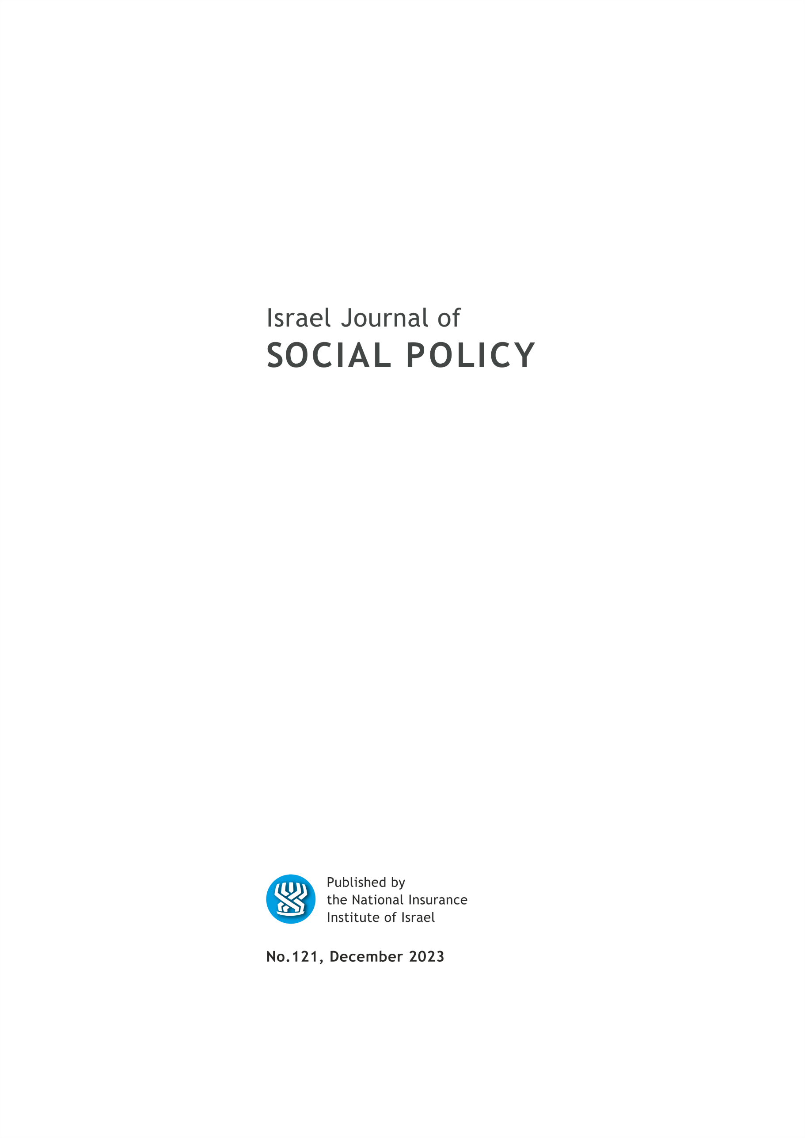

EDITORIAL BOARD

Israel (Issi) Doron, Editor in chief
Nitsa (Kaliner) Kasir, Chairman
Suliman Abu Bader
Leah Achdut
Jon Anson
Liat Ayalon
Orly Benjamin
Nissim Cohen
Sylvie Fogiel-Bijaoui
John Gal
Jochanan Stessman
Aviad Tur-Sinai

Managing Editor: Maya Orev-Attal
Typesetting: Onit Computer Services Ltd.

Contents
Developing intergenerational sustainability:
Recovery-oriented social policy and opportunities for the implementation of critical social policy
Donna Baines
Dementia in Isarel: New drugs, new technologies and the risk of widening the gaps in dementia care
Doron Merims and Tania Boguslavsky
Arabs in Israel: The connection between settlement pattern, capital types and exclusion and the risk of mortality
Matan Markovizky and Yonathan Anson
Workers with invisible disability:
The case study of family mediterranean fever (FMF)
Einav Haya Tzarfati Ninyo and Lilach Lurie
Things seen from here, unseen from there: A qualitative analysis of the eating disorder mentoring relationship
Shiran Elmalah-Alon and Roni Elran-Barak
Documentary photography as political action
Michal Krumer-Nevo

Summaries of the main articles

Developing intergenerational sustainability:
Recovery-oriented social policy and opportunities for the implementation of critical social policy
Donna Baines

ESPANET, Israel annual meeting conference was, held at the University of Haifa on February 15, 2023. The theme of the conference was intergenerational sustainability. The title of the conference was “Social policy as multi-generational sustainability: The starting point of social policy as sustainability”. The title followed contemporary approaches claiming that a social policy that enables sustainability is one that goes beyond the well-being of individuals at a given moment and should be formulated in a way that aims at reducing social, economic, gender, ethnic, and racial inequality focusing on future generations. Indeed, in recent years, we have seen the strengthening of the stance arguing that sustainability is not only a climatic matter alone and that economic and social sustainability are just as important. This approach connects directly to the UN Sustainable Development Goals.
We were honored to have Prof. Donna Baines as our plenary speaker. Prof. Baines has written extensively on anti-oppressive practice in social work which she developed as a critical framework that guides us in challenging and dismantling oppressive structures and practices. It requires social workers to critically reflect on their values, beliefs, and biases and actively work to eliminate oppressive systems and practices. In her opening presentation, Prof. Baines connected her approach to critical social work to our theme, presenting a fascinating practice-focused talk: “Developing Intergenerational Sustainability - Recovery-oriented Social Policy and Opportunities for the Implementation of Critical Social Policy Implementation”.
The conference dealt with the challenges facing the welfare state and social services while examining policy Social as a multi-generational project. In this context, Prof. Baynes analyzed the neo-liberal state after COVID-19 and gave an instructive lecture that provided us with a glimpse of what we can do for a better future world. The full translation of the lecture into Hebrew was carefully read and corrected by Prof. Orly Benjamin from Bar Ilan University, and a preface by Nessi Cohen and Einat Lavee.

Dementia in Isarel: New drugs, new technologies and the risk of widening the gaps in dementia care
Doron Merims² and Tania Boguslavsky

As life expectancy increases, so does the prevalence of diseases that cause dementia.
Until recently, the main recommendations for postponing the onset of dementia were lifestyle changes, especially diet and physical activity.
In recent years, there has been a revolution in the diagnosis and treatment of dementia. New technological tools such as advanced imaging devices are available for detecting pathological changes before clinical signs appear. In 2021, the U.S. Food and Drug Administration (FDA) approved the first drug directed at modifying the course of Alzheimer's disease. Combining early diagnosis with disease-modifying treatments may postpone and even prevent the onset of diseases that cause dementia.
Investing resources in research and development of early detection tools and drug treatments to delay or prevent degenerative brain diseases is encouraged and welcomed. At the same time, it is important to keep in mind that there is a long way to go in order to reach this goal, and currently there are no drugs proven effective and safe in preventing dementia.
In this article, we emphasize the importance of developing services for patients with dementia, especially in advanced stages, and warn against biasing attention and allocating human and economic resources to interventions that have the potential to prevent dementia and the possible neglect of care for patients with dementia in advanced stages. This policy may particularly harm patients of low socioeconomic status and those living in the periphery of the State of Israel.
Few in society need more help and support than people with dementia and their caregivers. Raising awareness of this devastating medical condition and dedicating financial and quality human resources is a paramount national challenge.

Arabs in Israel: The connection between settlement pattern, capital types and exclusion and the risk of mortality
Matan Markovizky and Yonathan Anson

The society in which we live is constructed as a hierarchy, whereby the higher the ranking within the social hierarchy, the lower the risk of mortality. Although this hierarchy is based on a range of levels that constitute the complete social structure, it is not a simple ladder. Instead, it encompasses three types of discrete yet intertwined capital: economical, cultural, and social. Economical capital refers to a person’s material resources; cultural capital refers to a person’s training (such as an academic degree) and acquired valuable social knowledge; and social capital refers to the value (economic and cultural) of others with whom the person conducts social relationships.
The literature presents two additional components of the social structure that are important and influence the risk of mortality: social consolidation (also conveyed through familial solidarity) that decreases the risk of mortality and social exclusion that increases the risk of mortality. Social cohesion relates to a person intertwined in a tight and supportive social network, whereas social exclusion refers to obstacles that people face on their way to acquiring different types of capital.
The Arab-Palestinian population in Israel possesses lower levels of capital compared to the Jewish population and is more vulnerable to exclusion and to being pushed into the margins of society. On the other hand, this population has greater familial solidarity – as a result of its more stable and traditional family structure compared to Jewish society.
However, the Arab society in Israel is also unique in that most of its population lives in homogenous towns in which all residents are Arabs who live relatively autonomous lives that are conducted in their native Arab language. This study examines the influence of the towns in which the Arab population lives – homogenous or mixed – on the risk of mortality, regardless of exclusion, solidarity, and social capital. By doing so, we also further explain these terms and how they can be measured. The study is based on 1995 census data and on mortality data up until the end of 2001 (six years in total) – in order to examine the impact of the type of town in with this population lives on mortality, as well as the influence of exclusion, solidarity, and types of capital. The study hypothesized that the Arab population in mixed towns will be at higher risk for premature mortality compared to those living in homogenous Arab towns. The findings supported our hypotheses. Not only do solidarity, lack of exclusion, and capital decrease the risk of mortality, but we also found that the Arab population living in homogenous towns is more “immune” to mortality compared to those living in mixed towns. This positive influence of social cohesion is reinforced by our findings that the Arab population living in small homogenous towns has lower rates of mortality (when eliminating additional influencing factors), even compared to the Arab population living in homogeneous municipal towns.

Workers with invisible disability:
The case study of family mediterranean fever (FMF)
Einav Haya Tzarfati Ninyo and Lilach Lurie

This article studies the integration of individuals with invisible disability in the Israeli labor market through a case study of workers with familial mediterranean fever (FMF). FMF is a chronic disease without any permanent external visible effects. The number of FMF patients in Israel (as well as elsewhere) is relatively low compared to many other chronic diseases. FMF disease has so far received only partial recognition from Israel’s National Insurance Institute. The study examines the factors that assist people with FMF to integrate into the labor market and the challenges that workers with FMF face. The study also examines the decision of workers with FMF to disclose their illness or to leave it hidden. For the purpose of the study, twenty semi-structured interviews were conducted with FMF patients (aged 28-59).
A number of insights emerge from the research and interviews. First, the interviewees expressed a desire that the state will take more responsibility with regard to the costs involved in their employment, particularly in payments of sick days to employees and the self-employed alike. Second, the study emphasizes the importance of employers’ familiarity with the disease. According to the study, employers – who are familiar with FMF – have the necessary tools to adapt the workplace to employment of workers with FMF. Third, the study shows the importance of employees’ familiarity with FMF. In some of the interviews, the workers attested to a sense of liberation that comes with coming out of the closet of disability and to a sense of belonging to the new community that is emerging – the community of people with FMF.

Things seen from here, unseen from there:
A qualitative analysis of the eating disorder mentoring relationship
Shiran Elmalah-Alon⁷ and Roni Elran-Barak

Background: Eating disorders (EDs) are chronic and complex disorders characterized by a variety of eating-related problems and emotional factors. Individuals with EDs often require extended periods of intensive rehabilitation to address their condition, and this rehabilitation may involve mentoring as a part of the treatment approach. Mentors, who are nonprofessional workers, regularly visit patients at their homes multiple times a week. Their role is to provide support and guidance within the context of the patient’s recovery process. Aims: To better understand the experience of mentoring, from the perspective of both patients and mentors. Methods: Fifteen in-depth qualitative interviews were conducted with patients and mentors. Results: The mentoring relationship is described using four themes. The first and second themes focus on the benefits and opportunities inherent in the mentoring dynamic. These positive aspects are closely tied to the mentor’s entry into the patient’s home space, which contributes to breaking the ED concealment cycle. The third and fourth themes shed light on the challenges encountered in the mentoring relationship, including conflicts between the mentor and patient, as well as the complexities surrounding issues of equality and reciprocity. Discussion: The analysis reveals the importance and uniqueness of the mentoring relationship and its contribution to the rehabilitation process of people with chronic EDs.

Documentary photography as political action
Michal Krumer-Nevo

This article’s aims are to promote thought and discussion in the field of social work regarding the contribution of visual images to the construction of people in poverty as others, and to propose ways of creating alternative, politicized and critical visual representations. The article starts with a discussion of the ethical complexity of documentary photography and continues with a review of different forms of poverty images, distinguishing between photographs that create othering of people living in poverty and photographs that produce “counter-visuality”, i.e. managing to resist othering. Through this move, the article will attempt to clarify the othering and distancing potential of popular visual images, to make the process of watching such images more conscious and political, and to propose possibilities for othering-resistant photography.

The University of British Columbia, Canada.
Shoham Geriatric hospital.
Western Galilee Collage, Department of Education.
Department of Social Work, Ben-Gurion University of the Negev.
Meitav Investment House.
Department of Labor Studies, Tel-Aviv University.
Faculty of Social Welfare and Health Sciences, University of Haifa.
Spitzer Department of Social Work, Ben-Gurion University of the Negev.

